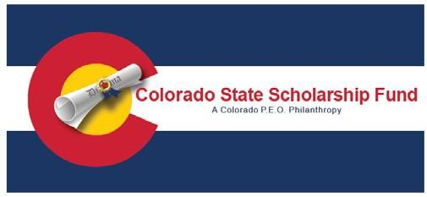
A C O L O R A D O P. E. O . P H I L A N T H R OPY

Stamp
Your Chapter
Return Address
Address Label for
Local High School Guidance Counselor

The current P.E.O.
Executive Treasurer
Contact information can be found on the Colorado State P.E.O. Website.

2022-2023
Committee Membership Contact Information

Chair, Diane Gallagher, CU
(2019-2023)
Dianegallagher48@gmail.com
(303) 929-3475
6425 S Galena St.
Englewood, CO 80111

Sara Canfield, EG (2021-2024)
Jkc19307@msn.com
(970) 768-1968
19307 County Road Q
Fort Morgan, CO 80701-7113

Janet Hokanson, DY (2022-2025)
janethokanson@gmail.com
(970) 243-9477
(970) 270-7291
734 Woodridge Court
Grand Junction, CO. 81505

CSC Adviser – State Treasurer Kathy Pirie, JH
peo.kwirekat@gmail.com
(303) 250-2592 (CELL)
8580 N County Line Rd
Longmont, CO. 80503

Colorado State Scholarship Fund (CSSF) History

The Colorado State Scholarship Fund was approved at Convention of Colorado State Chapter in June, 2007 and established in the P.E.O. Foundation in 2007.

Scholarship Applicant Requirements Preference will be given for non-traditional or vocational areas of study.

Qualifications
- Colorado residency and U.S. citizen- ship.
- High School graduation or GED date must be 2022-2023.
- No longer than two years past high school graduation or GED date.
- Submission of a completed application by the stated deadline on the form.
- Must not be related to anyone on the selection committee.

Other Application Requirements
- Completed and signed application (available at www.coloradopeo.org)
- Postmarked or emailed by January 31st
- Two (2) letters of reference from non-family members
- Description of school and community activities and involvement

Colorado State Scholarship Fund General Information

- CSSF is funded through donations to the P.E.O. Foundation.

- The amount(s) of the annual scholar- ship is no less than $1,000 each but amount may increase with the performance of the foundation and donations to the scholarship.

- Application forms are found on the Colorado State P.E.O. website http://www.coloradopeo.org

- The application period is open from November 1st, to January 31st.

- The scholarship(s) is awarded annually and announced April 30th.

- Where possible, the award will be given to the recipient during her award ceremony or graduation.

- Please copy and deliver this brochure to your local high school counselor for assistance in identifying possible applicants.

