Application Form 2022-2023
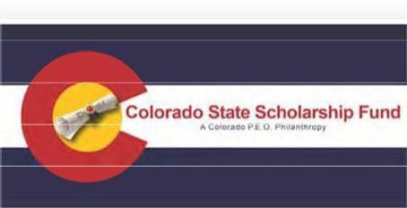

Colorado State Scholarship Award
Awards determined annually, but no less than $1,000 each.
ALL FIELDS MUST HAVE AN ANSWER OR THE APPLICATION
WON’T BECONSIDERED.
YES, NO OR N/A ARE ACCEPTABLE ANSWERS
THE APPLICATION MUST BE SIGNED AND DATED
Full Name: SSN/ID: _xxx‐xx‐ Birthdate:

Complete Physical & Mailing Address (street name, city, state & zip):

Applicant’s E‐mail address (personal email):

Applicant’s Phone Number:

Parent or Guardian Name and E‐mail address:

Intended School: Planned Entry Date:

School Address:

Course of study: Expected completion:

Planned use of funds (tuition, books, fees, etc.):

Estimated yearly cost to attend:

Name of High School:

High School or GED graduation date:

GPA: Class Rank: Class Size:

Are you related to:
(With the exception of the first question below, answers will not affect the selection outcome, information needed for the P.E.O. Foundation)

Anyone on the selection committee? A member of the P.E.O. Sisterhood?
A trustee of P. E. O. Foundation or an officer of the P.E. O. Sisterhood? A grantor or substantial contributor to P.E.O. or their family members?
A corporation controlled by a grantor or substantial contributor to P.E.O.? If yes to any answer, please describe and provide name:

Your signed name: Date:

Postmark date for completed scholarship application and requirements are due by January 31, 2023.
Email date & timestamp for completed scholarship application & requirements are due by Jan. 31, 2023, 10:00 p.m.

Colorado State Chapter Scholarship Fund

Colorado State Chapter Scholarship Fund was established in 2007 by the Colorado State Chapter of the P.E.O. Sisterhood. The Sisterhood was established in 1869 by seven young women attending Iowa Wesleyan College, and is a philanthropic educational organization interested in furthering educational opportunities for women.

Colorado State Scholarship Fund Annual award minimum $1,000 each.
Preference given for:
Non‐Traditional/Vocational
areas of Study

Eligibility and Selection Criteria

- Female Colorado resident
- 2022-2023 high school senior or GED graduate
- No longer than two years past high school graduation or GED date.
- Fulfillment of all application requirements (use as a check list):
  - Completed and signed application Please print or type
  - Two (2) SIGNED letters of reference of character, from non‐family members
  - Description of school and community activities and involvements
  - Most recent transcript(s)
  - Personal statement, letter or essay including:
    - Discussion of your plans and goals
    - Emphasis on how this scholarship will be beneficial to you
    - Any special circumstances/family situations which will give insight for the selection process
    - Any important experiences or significant people who have inspired or encouraged you
    - Please do not staple or use report covers.

Applications accepted only between the dates of November 1, 2022– January 31, 2023. Applications may be mailed or emailed. Email application MUST include ALL required information in a single PDF file. Any other format will not be accepted.
Postmark Deadline: January 31, 2023 (late applications will not be accepted)
EMAIL Deadline: January 31, 2023, 10:00 p.m. MST (late applications will not be accepted)

Recipients will be notified no later than April 15, 2023. Notifications will be sent to the email address on file for both the applicant and her parents/guardians. Please make certain you have provided email addresses that will be monitored on a daily basis.

Mail or email completed application and all required materials to:

Diane Gallagher, Chairman
dianegallagher48@gmail.com
6425 South Galena Court
Englewood, CO 80111
303-929-3475

