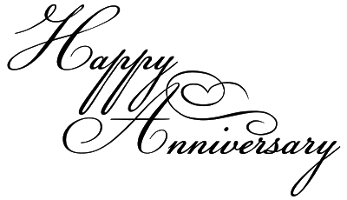

120 Years
2021 Celebrations

B | Las Animas | June 18, 1901
C | Colorado Springs | November 18, 1901
D | Lamar | December 11, 1901

100 Years
BJ Yuma December 9, 1921

75 Years
DF Denver February 18, 1946
DG Denver May 15, 1946

50 Years
GB Boulder May 1, 1971

