Unaudited Financial Reports
These unaudited reports for the Colorado P.E.O. Charitable Corporation include Chapter House operations, the Marguerite Fund, and the board that oversees and administrates those two programs.
Income by category
1 Apr 2019 – 13 Nov 2019
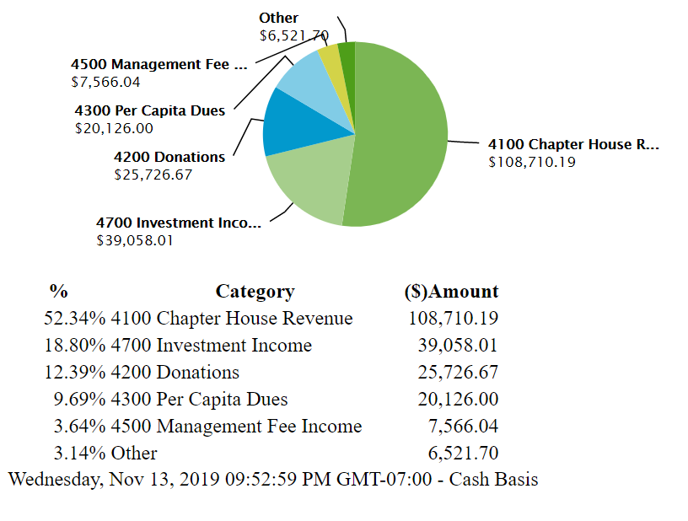Percent shown is the percent of total revenue.
Categories of revenue:
• Chapter House Revenue comes from residents, guest rooms, and meals.
• Investment Income includes interest, dividends, realized and unrealized gains and losses from our professionally invested investments. Investment fees are subtracted from the total.
• Per Capita Dues income has been discontinued.
• Donations are received from local chapters and individuals.
• Management Fee Income is the small amount earned by the board from interest and dividend income transferred from the Marguerite Fund and the Chapter House. This helps offsets the board’s expenses to manage these two programs.

Expense by category
1 Apr 2019 – 13 Nov 2019

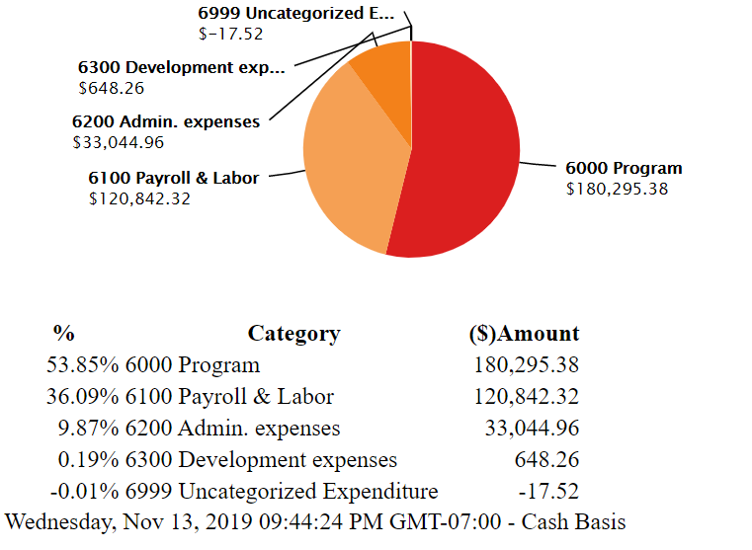Categories of expenditures:
• Program expenses include Marguerite Fund and Share the Care assistance and Chapter House expenses such as insurance, repairs and maintenance, utilities, groceries, and supplies.
• Payroll and Labor includes payroll and taxes for the Chapter House kitchen and grounds staff, administrative staff and other contract labor to support the Chapter House.
• Administrative expenses include accounting and legal expenses, management fee expenses, board reimbursement expenses, and payroll processing fees. The books are audited each year by a CPA firm.
• Development expenses include advertising, convention expenses and marketing expenses.
Thank you for your support!
Questions? Please contact us at coloradopeocharitableco@gmail.com
Unaudited Financial Reports

